SIMATS ENGINEERING
ASSESSMENT TOOL 1
Experiments

COURSE NAME: OBJECT ORIENTED ANALYSIS AND DESIGN
COURSE CODE: CSA11

COURSE OUTCOME COVERED

CO3: Analyze system requirements using object-oriented techniques to identify classes, attributes, and relationships and develop use case models. (BL4)

Assessment Tool Weightage: 40%

QUESTIONS:4 Total Marks:40

- Develop a system using UML for implementing the Book Bank process. It should verify the details of the student by the central computer. The details regarding the student will be provided to the central computer through the administrator in the book bank and the computer will verify the details of the student and provide approval to the office. Then the books that are needed by the student will issue from the office to him.

- Develop a system using UML for implementing the Exam Registration Portal. It should verify the details of the candidate by the central computer. The details regarding the candidate will be provided to the central computer through the administrator and the computer will verify the details of the candidate and provide approval. Then the hall ticket will be issued from the office to the candidate.

- Develop a system using UML for implementing Stock Maintenance System. In this system, the customer can place orders and purchase items with the aid of the stock dealer and central stock system. These orders are verified and the items are delivered to the customer. Then the stock details are to be updated accordingly.

- Develop a system using UML for implementing Online Course Reservation System. This system is organized by the central management system. The student first browses and selects the desired course of their choice. The university then checks the availability of the seat if it is available the student is enrolled for the course.

Code of Conduct:
I N. Murali sai (192372309) certify that this submission is my original work and that I have adhered to the guidelines specified for this assessment.
I understand that any violation of academic integrity rules will result in disciplinary action.
Signature of the student:

RUBRICS FOR CALCULATION:

Experiments

Criteria | Weightage | Level 4 – Exemplary | Level 3 – Proficient | Level 2 – Developing | Level 1 – Beginning
Understanding of Concepts | 25 | Demonstrates thorough understanding and effectively integrates multiple concepts/technologies | Good understanding with proper integration of most concepts | Basic understanding; limited or partial integration | Poor understanding; unable to integrate concepts
Experimental Design | 30 | Well-planned, systematic implementation with optimal solution | Correct implementation with minor issues | Basic implementation with errors or inefficiencies | Incorrect or incomplete implementation
Use of Tools | 20 | Effective and advanced use of tools/technologies with proper configuration | Appropriate use of tools with correct execution | Limited or inconsistent use of tools | Incorrect or minimal use of tools
Analysis of Results | 15 | Insightful analysis with accurate interpretation and validation of results | Good analysis with reasonable interpretation | Basic analysis with limited insights | Poor or incorrect analysis of results
Documentation | 10 | Clear, well-structured documentation with diagrams, code, and results | Organized documentation with necessary details | Basic documentation with missing details | Poor or incomplete documentation

Experiment 1: Book Bank Process
System Analysis
The Book Bank process involves a Student who requests books, an Administrator who records and submits the student's details, a Central Computer that verifies those details and grants approval, and an Office that issues the requested books once approval is received. The requirement to 'verify details' and 'provide approval' before books are issued indicates an <<include>> dependency between requesting/submitting, verification, and issuing.
Use Case Diagram
Actors identified: Student (primary), Administrator (primary), Office (primary), Central Computer (secondary/automated verification actor).
- Request Books <<include>> Verify Student Details — a request cannot proceed without verification.
- Submit Student Details <<include>> Verify Student Details — administrator-submitted data is always checked.
- Verify Student Details <<include>> Approve Request — verification leads directly to an approval decision.
- Issue Books <<include>> Approve Request — books can only be issued once approval exists.
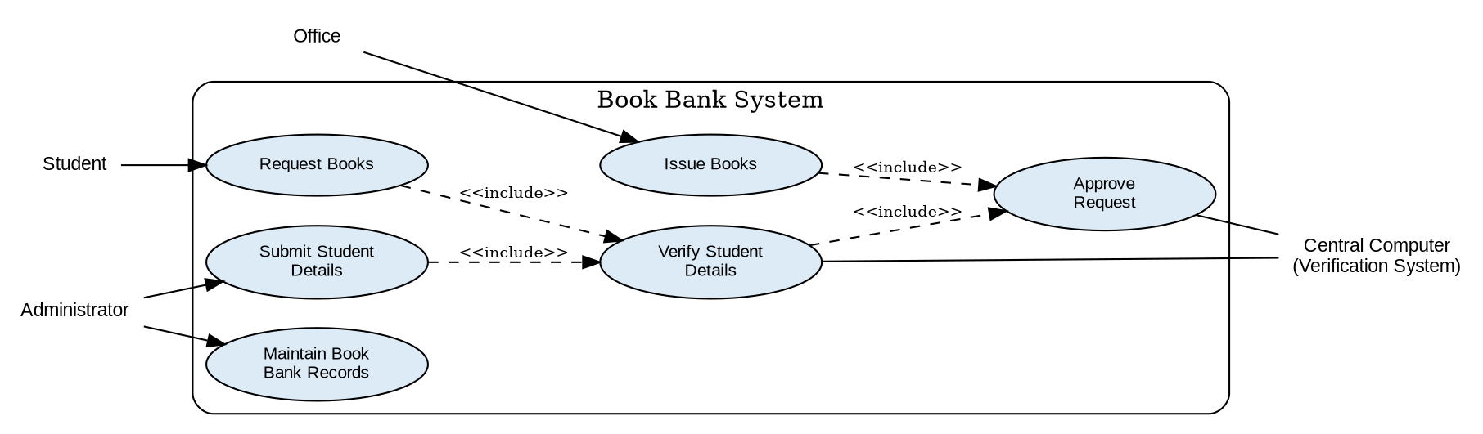
Figure 1.1: Use Case Diagram — Book Bank System
Class Diagram
Key classes identified: Student, Administrator, CentralComputer, Office, Book, and IssueRecord (association class capturing each issue transaction), with their attributes and operations shown below.
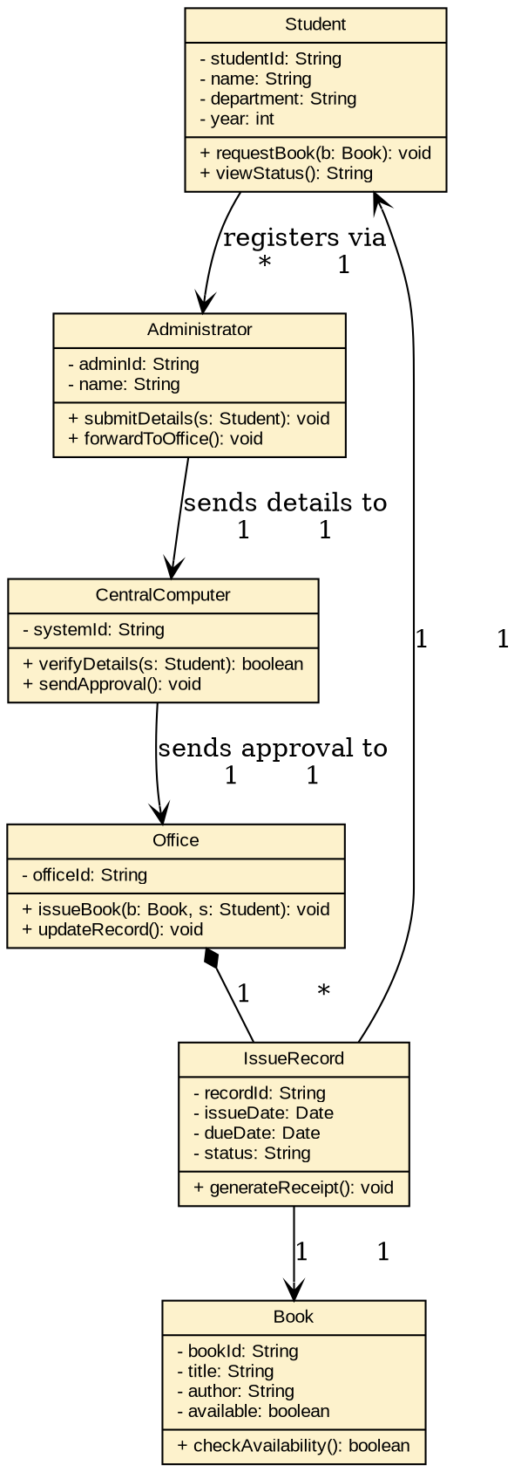
Figure 1.2: Class Diagram — Book Bank System

Experiment 2: Exam Registration Portal
System Analysis
The Exam Registration Portal follows a similar verification-and-approval pattern: a Candidate registers for an exam, an Administrator submits the candidate's details, the Central Computer verifies the details and grants approval, and the Office issues the Hall Ticket once approval is confirmed. Fee payment is modelled as an optional extension of registration.
Use Case Diagram
- Register for Exam <<include>> Submit Candidate Details, which in turn <<include>>s Verify Candidate Details.
- Verify Candidate Details <<include>> Approve Registration.
- Issue Hall Ticket <<include>> Approve Registration — the hall ticket is only produced after approval.
- Register for Exam <<extend>> Pay Registration Fee — fee payment is an optional/conditional extension point.
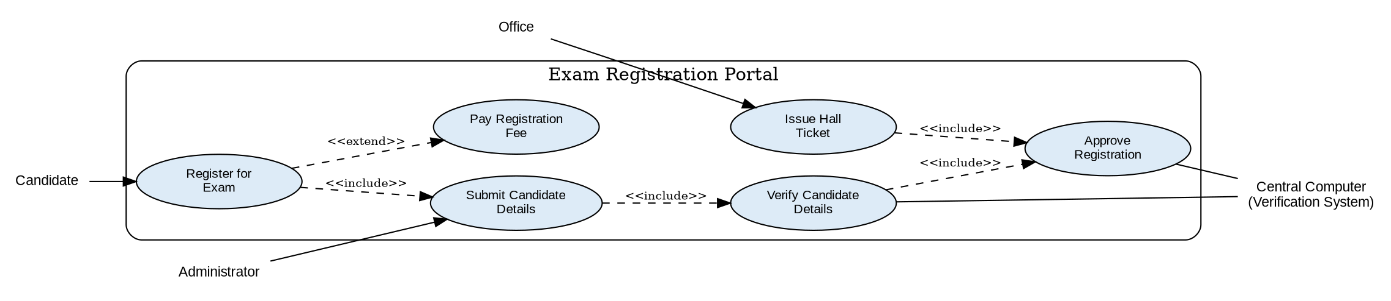
Figure 2.1: Use Case Diagram — Exam Registration Portal
Class Diagram
Key classes identified: Candidate, Administrator, CentralComputer, Office, ExamRegistration, and HallTicket, with attributes and operations shown below.
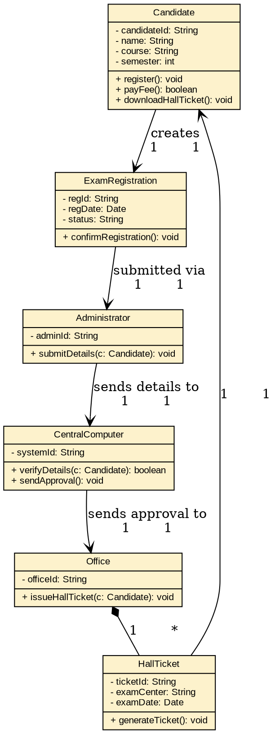
Figure 2.2: Class Diagram — Exam Registration Portal

Experiment 3: Stock Maintenance System
System Analysis
The Stock Maintenance System involves a Customer who places orders and purchases items, a Stock Dealer who verifies orders and delivers items, and a Central Stock System that maintains stock availability and is updated after every delivery. Placing an order requires checking stock availability, and every delivery triggers a stock update.
Use Case Diagram
- Place Order <<include>> Check Stock Availability — availability must be confirmed before an order is accepted.
- Purchase Item <<include>> Verify Order, which <<include>>s Deliver Item.
- Deliver Item <<include>> Update Stock Details — completing a delivery always updates the stock record.
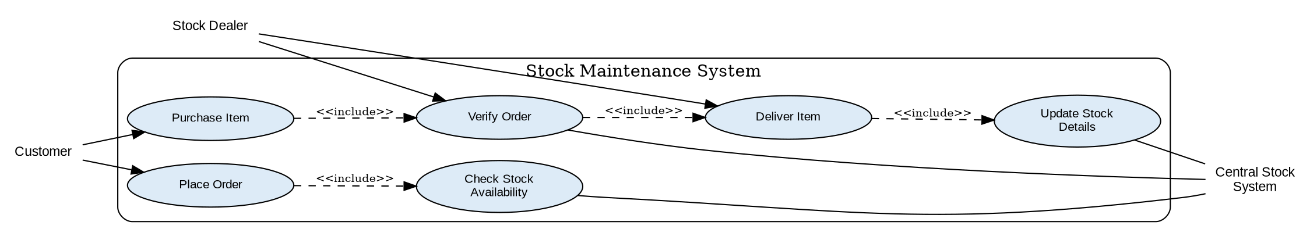
Figure 3.1: Use Case Diagram — Stock Maintenance System
Class Diagram
Key classes identified: Customer, StockDealer, CentralStockSystem, Order, Item, and Delivery, with attributes and operations shown below.
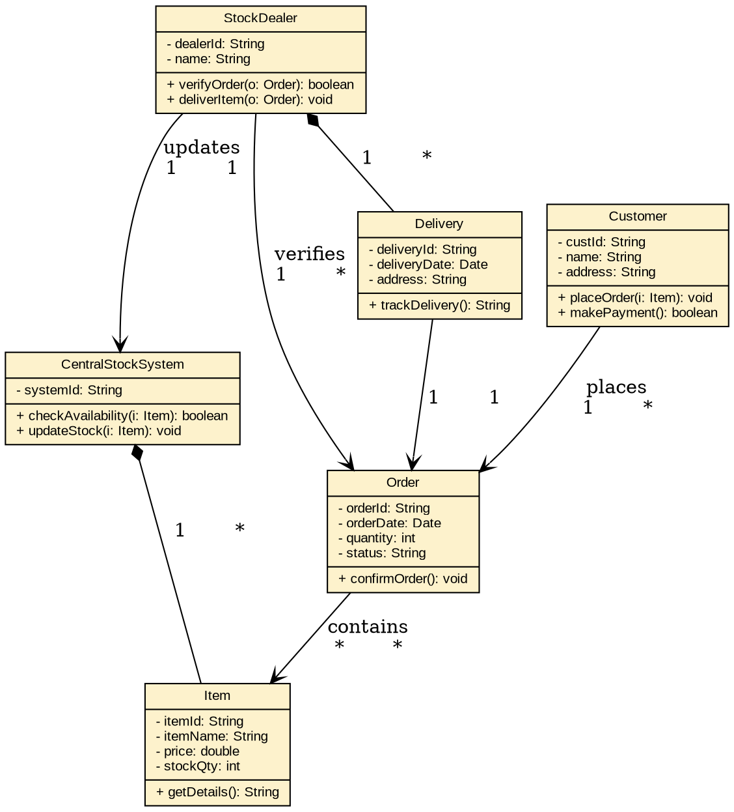
Figure 3.2: Class Diagram — Stock Maintenance System

Experiment 4: Online Course Reservation System
System Analysis
The Online Course Reservation System is organized by a Central Management System (the university). A Student browses and selects a desired course; the system then checks seat availability, and if a seat is available the student is enrolled. If no seat is available, the student may join a waitlist, modelled as an optional extension.
Use Case Diagram
- Select Course <<include>> Check Seat Availability — availability is always checked before enrollment can proceed.
- Check Seat Availability <<include>> Enroll in Course — enrollment directly follows a successful availability check.
- Check Seat Availability <<extend>> Join Waitlist — waitlisting is an optional path taken only when no seat is available.
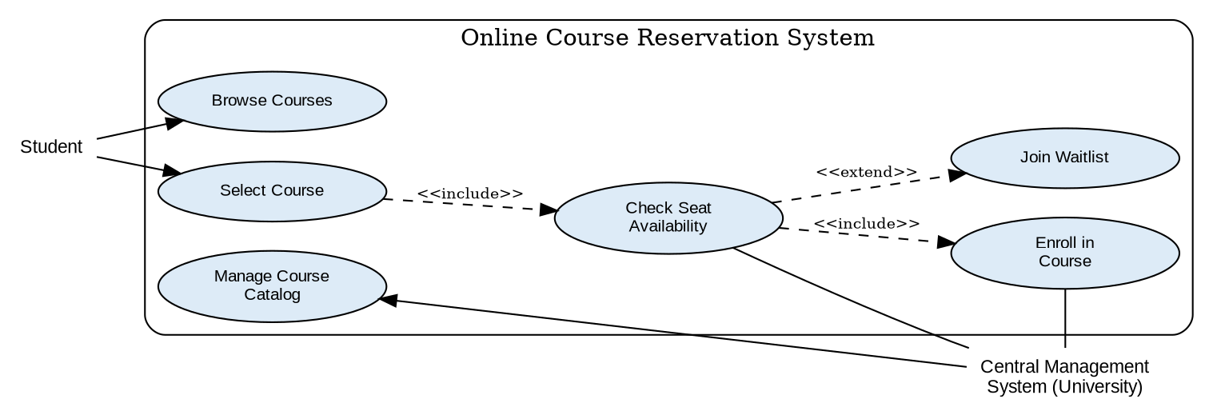
Figure 4.1: Use Case Diagram — Online Course Reservation System
Class Diagram
Key classes identified: Student, CentralManagementSystem, Course, Enrollment, and Waitlist, with attributes and operations shown below.
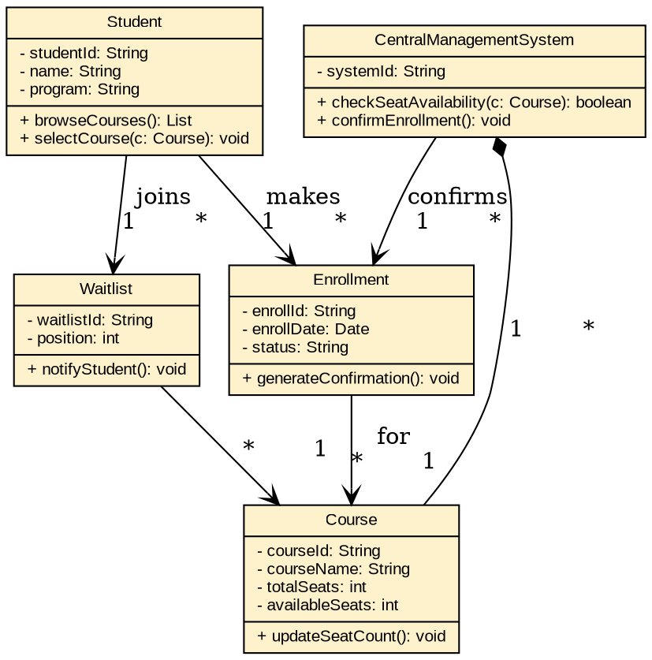
Figure 4.2: Class Diagram — Online Course Reservation System

